As a **member** of the society, you will contribute to the society through your own decision to **volunteer** at events, attend events, or be a **facilitator** at the **Interpretive Center** located at the **St. Eugene Mission Resort** located North of Cranbrook, BC. You will be able to attend the **Annual Gathering Meeting**, and participate in events, business decisions, and **voting** for the new board members. Lastly, as a member you will also stay informed about different events and business that the society will be doing. As a member, you are **not required** to volunteer, attend or participate in events, or be a facilitator.

**ⱡkamnin̓tik Childrens Truth and Reconciliation Society Goals:**

* Encourages understanding and education of the history and cultures of the Ktunaxa Nation and Shuswap Indian Band people
* Supports the ability of survivors and inter-generational Kootenay Indian Residential School students to share their truths and create a better future for their children
* Advances truth and reconciliation of Canada with First Nations and our people
* Promotes the cultures and languages of the Ktunaxa Nation and Shuswap Indian Band family

I hereby ask the ⱡkamnin̓tik Childrens Truth and Reconciliation Society to accept my application for membership. I also grant the society permission to send me society communications, such as emails, mail, and social media.

Name: Indigenous

Nation/Affiliation: Tel. #: Email:

Mailing Address:

Town: Postal Code: Applicant Signature or

Parent/Guardian*: Date:

*\*Parental or guardian consent is required for anyone under 19 years of age.*

**Membership Category: Choose one below Rate**

* **Ancestor** – Ktunaxa Nation or Shuswap Indian Band recognized citizen, and who was a student and is a survivor of an Indian residential school including day school

**NO FEE**

Full-Voting

* **Descendant** – Ktunaxa Nation or Shuswap Indian Band recognized citizen, and who is a child of a student and survivor of an Indian residential school including day school

**NO FEE**

Full-Voting

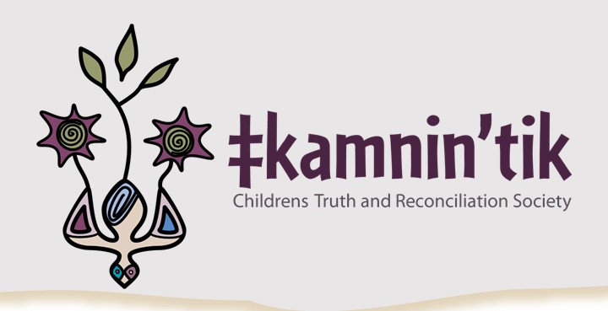

**Ktunaxa & Shuswap Band Citizen Membership Form**

What workshops, activities, or events would you like to **see offered** by the society?

Indicate if you are willing to **volunteer** and if so, what activities?  Yes  No  Prefer not to answer

**Send your completed registration form or questions to:**

**Email:** [members@tkamnintik.com](mailto:members@tkamnintik.com) or **Mail:** ŧkamnin’tik Childrens Truth and Reconciliation Society

[admin@tkamnintik.com](mailto:admin@tkamnintik.com) c/o 7777 Mission Road, Cranbrook, BC V1C 7E5

**Learn more at:** [www.tkamnintik.com](http://www.tkamnintik.com/)